

ADALINE

AND, OR logic gates and training on sample dataset



Sri sai vijaya aditya nittala

177163

841775

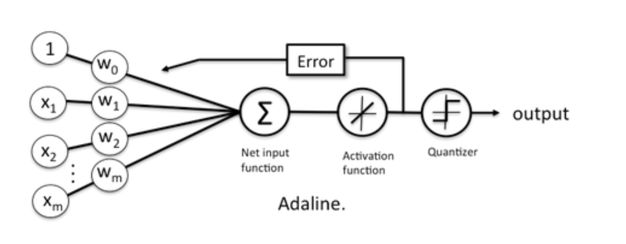The training of ADALINE follows the below diagram:

The algorithm is:

1. Initialize the weights and bias to a random number.
2. For each training iteration:
   1. Calculate the prediction Z as:
 $Z=W^{'}X+b=\sum_{i=1}^{m}{w_{i}x_{i}}+b$

     1. Where:
         1. Z = prediction
         2. W = weights
         3. X = Feature Vector
         4. b = bias
   2. Apply the activation function, which here is an identity function.
   3. Apply the Quantizer function, which is analogous to *threshold* in Perceptron learning algorithm, to get class labels for the training examples as O.
   4. Update the weights by performing backpropagation as:
 $W=W-(\frac{α}{m})∆W$

 $b=b- (\frac{α}{m})(Z-Y)$

    1. Where:
 $∆W=\left(Z-Y\right).X$

        1. Z = prediction
         2. Y = Correct labels
         3. X = Feature Vector
         4. α = learning rate
         5. m = no. of training examples.
3. Repeat for given number of iterations.

This algorithm is called ***Gradient Descent***, which finds the global minimum of the cost function J(W, b) with respect to the parameters W(weights) and b(bias):

$$J(W, b)= \frac{1}{m}\sum_{i=1}^{m}{{(z_{i}- y_{i})}^{2}}$$

* The code below implements the above algorithm on a sample data set as well as AND, OR gate.
* The sample training dataset has been normalized as it helps with performance as well as improves accuracy. ***Z-score*** normalization was used:
$d_{i}=\left(\frac{x_{i} - μ}{σ}\right)$

* Parameters chosen:
  + α = 0.1
  + Number of iterations = 25